Imagining the Imaginary: A Cultural-Intellectual History of the Complex Plane (1748–2025)

Introduction
In the mid-18th century, the “imaginary” number $i = \sqrt{-1}$ was a mathematical oddity – a useful algebraic fiction that even its name implied was not quite real[1]. Over the next 275 years, this humble symbol exploded into a rich two-dimensional concept: the complex plane. This is the story of how $i$ traveled from Euler’s pen in 1748 to the heart of modern technology and art in 2025. We will see how an algebraic trick became a visual plane one could draw, how practical problems like electricity and quantum waves pulled complex numbers into everyday use, and how thinkers from mathematicians to artists found evolving meanings in the complex plane – as a map of numbers, a model of waves, a canvas for beauty, and even a doorway to higher dimensions.

Algebraic Symbols (1748–1805): Making Peace with “Impossible” Numbers
In 1748, Leonhard Euler published his Introductio in analysin infinitorum, casually using $i$ in formulas and famously linking it to real trigonometry via Euler’s formula $e^{i\theta} = \cos\theta + i\sin\theta$[2]. Euler and his contemporaries treated $\sqrt{-1}$ as a useful symbolic tool, but its status was questionable – René Descartes had coined the term “imaginary” a century earlier as a dismissive label for numbers that should not exist[1]. Indeed, Descartes contrasted these imaginary numbers with the normal “real” numbers he accepted[1]. Early mathematicians like Jean d’Alembert began cautiously exploring these entities: in the 1740s d’Alembert showed that one could handle complex quantities algebraically in a consistent way, even attempting (incompletely) to prove that every polynomial equation has a root of the form $a + bi$[3]. Still, for many 18th-century savants, $i$ was an “impossible” number – a bookkeeping device to be manipulated and then made to cancel out in final results. It had no physical or geometric meaning, only algebraic utility. As the French Encyclopedia of 1751 pointedly omitted any discussion of imaginary numbers[4], one senses an unease: these symbols worked in equations, but were they real or just mental phantom?
Despite the skepticism, Euler’s prowess with complex formulas (like Euler’s identity $e^{i\pi}+1=0$) hinted at a deeper coherence. Mathematicians found that using $i$ could simplify calculations dramatically. By the late 1700s, certain problems (e.g. integrating real functions or solving cubic equations) virtually required venturing into the complex domain[5][6]. The concept gained grudging acceptance as a formal extension of the real numbers. As the 19th century dawned, complex numbers were still seen as “algebraic ghosts” – but that was about to change when a few bold thinkers re-imagined them in a very literal way.

A Plane You Can Draw (1806–1831): Geometry Gives Reality to the Imaginary
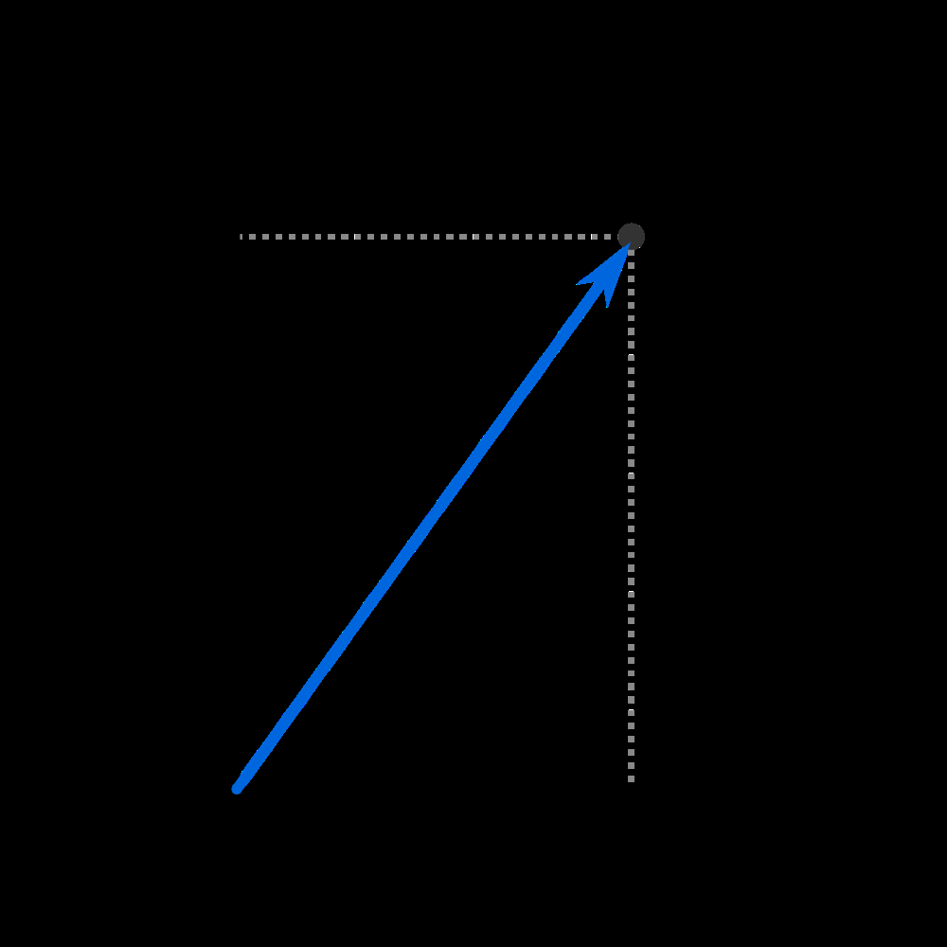
In 1806, Jean-Robert Argand introduced a diagrammatic view of complex numbers: each complex $z = a + bi$ could be plotted as a point $(a,b)$ on a plane, now called the Argand diagram. This simple picture turned the mysterious $\sqrt{-1}$ into a 90° rotation on paper, making “imaginary” quantities as tangible as horizontal and vertical distances[7][8]. Argand – an amateur mathematician – published an essay in which he treated $i$ not as an impossible unit but as an operator that turns the real axis to the imaginary axis (a quarter turn)[7]. The magnitude of a complex number became its distance from the origin (a concept Argand also pioneered), and adding complex numbers corresponded to adding vectors.
Argand’s contemporaries were initially skeptical. When the famed mathematician Legendre first heard of Argand’s idea, he admitted he “was very doubtful” that imaginaries could be “as real as the others.” But after reading Argand’s memoir, Legendre found “quite original ideas, very well presented,” yielding correct results in trigonometry and algebra[8]. He circulated Argand’s work, praising the young man who “represented [imaginary quantities] by lines” and treated them on par with reals[8]. This geometric metaphor – the complex plane – was a revelation. It allowed people to see $a+bi$ as a point or arrow in a plane, rather than a formal $a+bi$ string of symbols. The once “imaginary” number had a home in ordinary space.
Unbeknownst to Argand, he had been scooped decades earlier by a Norwegian surveyor, Caspar Wessel. Wessel in 1797 had presented the same geometric interpretation of complex numbers as points/vectors, but published in Danish, his work went unnoticed[9][10]. It wasn’t until Argand’s essay (rediscovered and championed in 1813) and a subsequent push from greats like Carl Friedrich Gauss that the idea caught on. In 1831, Gauss – who had privately used complex plane ideas as early as 1800 – finally published a paper endorsing the geometric view of complex numbers[11]. With Gauss’s imprimatur, the Argand plane gained wide acceptance. Even initially hesitant mathematicians came around: by the 1840s, the influential Augustin Cauchy, who had earlier focused on algebraic formalism, updated his work to incorporate the complex plane visualization[12].
This era turned complex numbers from abstract “impossible” symbols into points one could plot with a pencil. The complex plane gave an intuitive reality to $i$: it was simply the axis perpendicular to the reals. Debates persisted – e.g. the mathematician Servois argued in 1814 that one should stick to algebraic manipulation, fearing geometry might mislead[13] – but the momentum was on the side of the pictorial view. The Argand diagram proved immensely fruitful. It made the fundamental theorem of algebra easier to grasp (Argand himself gave an early geometric proof that every polynomial has roots in the complex plane[14]) and it provided a common language for formerly “strange” numbers. By 1831, the metaphor of a “plane” of complex numbers was firmly established, and students thereafter learned to picture complex numbers as points moving in a plane, not just algebraic curiosities[7].

Functions & Flow (1831–1870): Complex Variables Meet Physics
Once the complex plane was accepted as a legitimate mathematical space, it became the playground for a new theory of functions. In the mid-19th century, mathematicians like Cauchy, Gauss, and Riemann developed complex analysis – the calculus of functions $f(z)$ where $z$ lies in the complex plane. They discovered that complex functions (under certain conditions) have astonishing properties: they are rigidly constrained and “holomorphic” (smooth), and integrating them along paths in the plane produces elegant results like Cauchy’s integral formula and the residue theorem. Crucially, geometry underpinned these advances. Cauchy initially had done algebraic manipulations with $a+bi$ forms[15], but he and others soon leveraged geometric intuition – integrating along loops in the complex plane, interpreting singular points as driving the value of integrals, etc. By 1851, Bernhard Riemann introduced the idea of Riemann surfaces: multi-sheeted extensions of the complex plane that allow multi-valued complex functions (like $\sqrt{z}$ or $\log z$) to be treated as single-valued on a clever layered surface[16][17]. This was a breakthrough in mathematical imagination – the complex plane could be warped, copied, and stitched into abstract surfaces so that functions became geographic maps from one surface to another. Riemann’s work fused the idea of the complex plane with topology and paved the way to modern analyses of space and dimension[18][19].
As complex analysis flourished, its power was quickly recognized in physics and engineering. Mathematical physicists found that two-dimensional fields – like the flow of an ideal fluid, or the distribution of electrical potential in a plane – could be elegantly described by complex analytic functions. Riemann showed that solving Laplace’s equation for potential flow in 2D is essentially the same as finding a holomorphic function: “Riemann virtually puts equality signs between two-dimensional potential theory and complex function theory”[20]. In practice, this meant that techniques of complex analysis (contour integration, conformal mapping) became standard tools to solve real-world problems in electrostatics, fluid flow, and heat conduction by the 1860s[20].
At the same time, the use of complex numbers began seeping into the nascent technologies of the Industrial Revolution. Irish mathematician William Rowan Hamilton had generalized complex numbers to quaternions (4D analogues) in the 1840s, but even plain complex numbers found uses: for instance, Joseph Fourier’s work on heat and vibrations used trigonometric series that can be neatly expressed with complex exponentials, connecting music and signal theory to complex algebra. And in the realm of telegraphy and circuits, a few innovators realized that oscillatory electric currents could be handled as complex numbers. In an 1868 paper, James Clerk Maxwell – better known for electromagnetism – solved an AC circuit problem by assuming solutions of the form $e^{i\omega t}$ (a complex exponential)[21][22]. This was essentially the phasor technique in embryo: representing a sinusoid by a rotating vector in the complex plane. Maxwell and others “proved the meal” (showed the method works) but never wrote the “recipe” in a formal way[23]. Still, by the 1870s the idea was clear: the complex plane was not just a static graph of numbers, but a dynamic medium in which waves and oscillations could be represented (a sine wave being a projection of a circle in the complex plane[24]). The complex plane had evolved from a static map into a framework for modeling change – a way to encode rotations, oscillations, and flows.
Philosophically, this era cemented the ontology of complex numbers: no longer “imaginary” at all, they were points and transformations on an equal footing with real numbers. The question “are imaginaries real?” was gradually rendered moot by success: wherever these complex quantities were applied, they provided real answers. As one 2023 retrospective in Scientific American noted, by the end of the 19th century complex numbers were accepted because of their usefulness, even if, officially, classical physics still insisted that measurable quantities be real numbers[25][26]. Complex numbers had proven themselves a fantastic tool for simplifying mathematics – it was easier to describe a light wave or alternating current with rotating complex fields than with oscillating real functions[27]. So even if an engineer claimed “of course the electric field is real, $i$ is just a calculation,” the complex plane had become indispensable. It was the secret sauce behind the scenes of many theories.

Modernism & Machines (1870–1945): Powering the World with Complex Numbers
By the late 19th century, complex numbers moved from chalkboards to concrete infrastructure. The rise of telegraphy, telephony, and electric power created a demand for mathematical methods to handle oscillatory signals and alternating currents. Enter the electrical engineer Charles Proteus Steinmetz, who in the 1890s championed the operational calculus and phasor method. Building on the hints of Maxwell and Oliver Heaviside, Steinmetz taught the engineering world that an AC voltage $V\cos(\omega t + \phi)$ could be treated as a complex number $V e^{i\phi}$ – a point in the complex plane that conveniently encapsulates magnitude and phase[28]. This simple representation turned the design of AC power systems from a nightmare of differential equations into straightforward algebra. As one account describes, prior researchers had anticipated this idea, but “Maxwell and Heaviside had proved the meal, but could not… write the recipe”[23] – it was Steinmetz who fully codified and popularized the method around 1893. Thanks to him, every electrical engineer began using the Argand plane (though they might call it the impedance plane or phasor diagram) to solve circuits. The complex plane had become a workhorse of modern technology: it helped light cities with AC power and connect continents with telephone and radio signals.
The cultural tone around complex numbers also shifted dramatically. What had once been an esoteric puzzle for mathematicians was now a practical necessity. Textbooks from the late 19th and early 20th centuries in engineering and physics routinely taught complex arithmetic. For example, by 1910 it was common to find “$j$-operators” (engineers often use $j$ instead of $i$ to avoid confusion with current) representing 90° phase shifts in circuit theory. The complex plane, in other words, quietly ran the machines of modernity. Its adoption in technology was not without resistance – older engineers had to be convinced that these imaginary numbers weren’t hocus-pocus – but the efficiency gains were undeniable. A Smith chart, invented in 1939 at Bell Labs, even allowed RF engineers to graphically solve complex impedance matching problems by plotting reflection coefficients on a circular complex grid. This analog nomogram (printed on paper) let wartime radar and radio technicians compute using the geometry of the complex plane, without any calculation at all – a testament to how concrete the “imaginary” plane had become in practice.
Meanwhile, in pure science, the meaning of the complex plane took another profound turn in the 1920s: quantum mechanics introduced the complex wave function. Erwin Schrödinger’s wave equation (1926) uses a complex amplitude $\Psi(x,t)$ to describe the state of a particle. Suddenly $i$ was not just a calculational convenience but an explicit part of fundamental physical law. This sparked philosophical debates: why should nature prefer complex numbers? Schrödinger himself was uneasy, writing in June 1926, “What is unpleasant here, and indeed directly to be objected to, is the use of complex numbers. $\Psi$ is surely fundamentally a real function.”[29]. He initially tried to reformulate his theory with two real equations instead of one complex equation[30]. But that approach proved clumsy, and the complex form prevailed. Over time, physicists realized that quantum theory’s elegant structure – the superposition principle, interference, and the ability to compose systems – works seamlessly with complex numbers and loses its simplicity if one forces everything to be real[31][26]. By mid-century, experiments (much later, even a 2020–21 test) showed that real-number formulations of quantum mechanics can fail to predict certain outcomes, whereas complex quantum theory succeeds[25][32]. In effect, nature itself seemed to “use” the complex plane, at least at the microscopic level. This was a philosophical vindication: imaginary numbers, once “fictitious,” now had a secure footing in physics’ most accurate theories. As Scientific American put it, “quantum physics falls apart without imaginary numbers”[25] – a dramatic turnaround from the days when they were thought to be mere artifacts of human math.
By 1945, the complex plane had thus infiltrated multiple layers of culture. It was a staple of higher education, a daily tool for engineers, and an accepted ingredient in scientific explanations. It also began to inspire cross-disciplinary curiosity. Economists and social scientists, for instance, borrowed terms like “complex growth poles” or toyed with models where oscillatory behaviors used complex eigenvalues. And in music theory, the Fourier analysis of sound (using $e^{i\omega t}$ components) became fundamental – linking the complex exponential to musical pitch and timbre. In these ways, the complex plane served as a bridge: connecting AC circuits and radio waves to trigonometry and exponentials, connecting abstract algebra to mechanical vibrations and beyond. The once puzzling plane of $a+bi$ had proven its worth by powering the modern world and deepening our understanding of reality.

Screens & Fractals (1945–1985): The Complex Plane as a Creative Canvas
In the post-war era, the complex plane underwent yet another transformation – into a vivid visual medium, thanks to the advent of computers and the rise of chaos theory. Mathematicians had long known that iterating simple complex functions could produce intricate patterns. Early 20th-century French mathematicians Gaston Julia and Pierre Fatou studied the recursive behavior of $z^2 + c$ (for complex $z$ and constant $c$), but without computers they could only sketch a few disconnected points. By the 1970s, however, computers could perform millions of iterations and plot the results on a screen or plotter. The Mandelbrot set, first plotted around 1980 at IBM by Benoît Mandelbrot, became an icon of this new era. It is defined in the complex plane (the set of $c$ values for which the iteration $z_{n+1}=z_n^2+c$ stays bounded) – essentially a map of the fate of Julia sets. When rendered visually, the Mandelbrot set is shockingly intricate: a bulbous black figure with infinite filigreed edges of spirals, lightning-bolt tendrils and self-repeating miniatures.
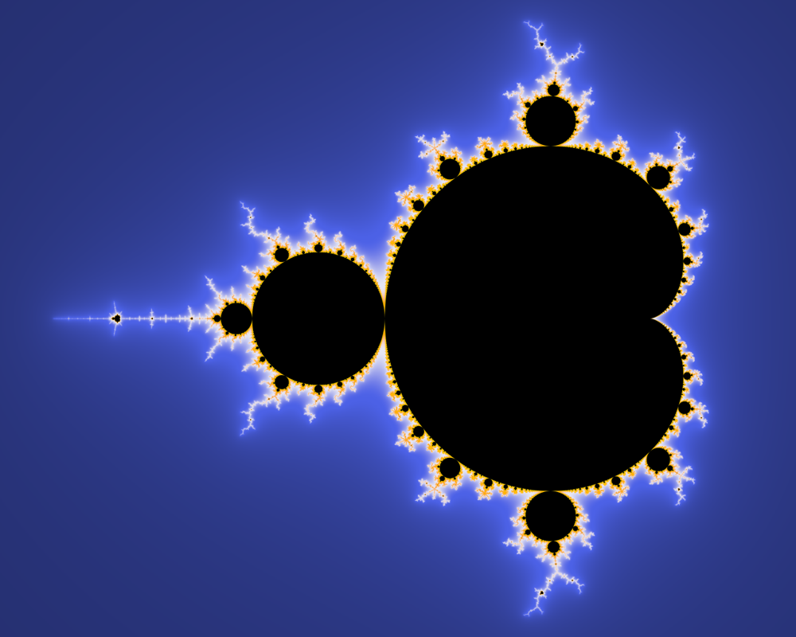
By the 1980s, the complex plane itself became a public spectacle through computer-generated fractals like the Mandelbrot set. This famous image (shown above) unfolded in “fiery tendrils” on the August 1985 cover of Scientific American, captivating a broad audience[33]. The impact was enormous. Suddenly, the frontiers of complex number research – once confined to academic journals – were on newsstands and television. The bug-like silhouette of the Mandelbrot set found its way onto dorm room posters worldwide[34]. Pop science magazines explained how to zoom into the complex plane to find “valleys of seahorses” and “spiral galaxies” hidden in the pattern[35]. It was psychedelic and profound: here was art created by complex numbers. The public was amazed that such infinite complexity and beauty could emerge from iterating $z^2 + c$.
The cultural resonance of this complex-plane art was significant. Within a few years, the Mandelbrot set and related fractals inspired highbrow and lowbrow culture alike. Esteemed artist David Hockney created paintings influenced by fractal forms[36]. Musicians composed fugues and electronic pieces structured by fractal patterns (echoing the self-similarity of the complex iterations)[36]. The mathematician John Hubbard remarked that the set held “a universe of ideas… a modern philosophy of art… bringing complex systems before a large public”[37]. Science fiction writer Arthur C. Clarke narrated a documentary (The Colours of Infinity, 1995) devoted entirely to fractals, calling them “the fingerprints of God” – all generated by points in the complex plane. The complex plane had escaped the lab and become part of pop culture. It represented chaos and order intertwined, a visual metaphor for complexity emerging from simple rules[38]. Even literary figures like John Updike wove the Mandelbrot set into fiction, using it as a metaphor for the boundary between truth and falsehood[39]. In classrooms, these images revitalized math education: students could see an explicit link between an equation and a colorful pattern, making the once-dry topic of complex numbers exciting and accessible.
On the scientific front, the complex plane continued to be a vital tool in computing and engineering. As digital signal processing developed (for radar, sonar, music synthesis, etc.), complex numbers were everywhere: the Fast Fourier Transform (FFT), invented in 1965, relies on decomposing a signal into complex exponentials. Engineers routinely visualized filter designs with poles and zeros plotted on the complex plane (an extension of the Argand diagram where system stability is judged by locations in the plane). The WWII-era Smith chart we mentioned remained in heavy use for RF design well into the computer age, though eventually software took over those graphical tasks. Complex analysis also found new application in chaos theory and non-linear dynamics (often via fractal geometry). For example, the study of Julia sets – each a tapestry of points in the plane that do not escape to infinity – became a rich field connecting complex function theory with topology and computer graphics. Thus, from roughly 1945 to 1985, the complex plane served both pragmatic needs (as a mathematical engine inside algorithms and simulations) and aesthetic ones (as the source of striking imagery and metaphors about nature’s complexity).
This era emphasized visualization and pedagogy: Colorful computer plots translated abstract complex formulas into pictures anyone could appreciate. The Argand diagram had been a static plot of points and vectors; now the complex plane was alive with color, evolving patterns, zoom animations on screens – truly a canvas for exploring mathematical beauty. The fact that a simple complex formula could generate something as endlessly intricate as the Mandelbrot set also touched on deeper philosophical questions about mathematics: Did these fractal shapes exist in some Platonic sense within the complex plane, or were they just by-products of our visualizing tool? Either way, by the 1980s the complex plane had firmly captured the public imagination as the locus of infinite complexity and art – a far cry from the “useless imaginary” numbers of Descartes. As one commentator noted, “It held a universe of ideas… a way of bringing complex systems before a large public.”[40] In the complex plane, people saw an analogue of nature’s complexity – and indeed Mandelbrot argued that fractals could model real-world phenomena (coastlines, clouds, stock market fluctuations) better than classical geometry. Thus the complex plane, through fractals, became a bridge between rigorous mathematics and the irregular forms of the natural world.

Networks & Qubits (1985–2025): The Complex Plane in a Connected, Quantum World
In the most recent decades, the complex plane has continued to evolve and integrate into cutting-edge science and technology. Even after the fractal fad of the 1980s subsided, the influence of those complex-plane visuals persisted. Computer art with Julia sets and Mandelbrot zooms became a genre of its own, now a bit retro but still captivating. More profoundly, the complex plane underlies the information revolution in less obvious ways. For example, every digital communication or networking system that uses Fourier transforms or signal modulation is implicitly using complex exponentials to encode data. The algorithms compressing images or enabling cell phone signals treat signals as functions in the complex frequency domain. So, the complex plane quietly powers the internet and modern media as a behind-the-scenes mathematical tool (much as it did for analog electronics earlier).
One striking new arena is quantum computing. As we noted, quantum theory is inherently complex-valued – a qubit’s state is described by a normalized complex two-vector. In quantum computing tutorials today, one often sees references to the Bloch sphere (which is a geometric way to represent a qubit’s complex state), and quantum logic gates are described by $2\times 2$ matrices of complex numbers (e.g. a phase gate multiplies the $|1\rangle$ state by $e^{i\theta}$, a rotation in the complex plane of that amplitude). The training of a new generation of scientists involves building intuition for these complex rotations. Recent research even provided experimental proof that complex numbers are indispensable in quantum mechanics’s predictions, not just a convenient convention[32][25]. This adds weight to the idea that the complex plane is in some sense embedded in the structure of reality. In practical terms, companies developing quantum computers must manipulate complex probability amplitudes with exquisite precision – literally turning abstract Argand-plane vectors by controlled angles to perform computations.
Another burgeoning field is machine learning and network theory. Here, the role of the complex plane is emerging in innovative ways. One example is in knowledge graph embeddings for AI: researchers have discovered that using complex vectors to represent relationships can capture certain patterns (like inverses or cyclic relations) more naturally than real vectors. A model called RotatE (2019) defines relations as rotations in the complex plane, so that to satisfy a relation $r: head \to tail$, the embedding of the tail is just the head’s embedding rotated by some angle associated with $r$[41]. In this way, the complex plane’s geometric property – angles on a circle – is harnessed to represent abstract knowledge. As one overview put it, “The complex plane provides a richer space to capture nuanced relationships” for embeddings[42], allowing AI systems to encode information in the phase (angle) of complex numbers in addition to magnitude. Complex-valued neural networks have also been applied in signal processing and physics-informed machine learning, where using complex weights can naturally model wave phenomena or symmetrical properties. In short, the complex plane has become an algorithmic tool in AI, offering new degrees of freedom to represent and learn from data.
The theme of higher dimensions also resurfaces: the complex plane ($2$D) was the gateway to quaternions ($4$D) and now to even larger structures. For instance, Roger Penrose’s work on quasicrystals and aperiodic tilings in the 1980s indirectly relates to complex numbers – the Penrose tiling can be generated by projecting a higher-dimensional cubic lattice down onto a plane, a process that uses complex phases (related to the golden ratio, which can be represented with complex exponentials on a 5-fold symmetric axis). Penrose popularized new non-repeating patterns that required complex algebra to understand, effectively showing how the complex plane could model quasi-periodic order in materials (quasicrystals discovered in 1984 have diffraction patterns explained by 4D or 6D complex lattices). These developments illustrate how the Argand plane concept has generalized – mathematicians and physicists now routinely think of complex spaces of many dimensions (complex projective spaces, Calabi–Yau manifolds in string theory, etc.), which build on the intuition of a 2D complex plane but take it to formidable abstract heights. The humble $a+bi$ is the start of a journey into spaces of $n$ complex dimensions (which equates to $2n$ real dimensions) that underpin advanced theories in physics.
In popular culture and outreach, complex numbers continue to hold intrigue. Modern math popularizers often mention Euler’s identity $e^{i\pi}=-1$ as an example of mathematical beauty (it frequently tops polls of the most beautiful formula). The TED talk circuit has even featured presentations on complex numbers in quantum computing, explaining how a quantum phase (a complex-plane angle) can encode information and create interference patterns. These talks and videos aim to convey to general audiences why we can’t “just remove $i$” from quantum equations – reinforcing the point that our world, from electrons to emerging quantum tech, truly runs on complex math. On the lighter side, the term “complex network” (unrelated to complex numbers, meaning complicated networks) sometimes causes playful confusion – but it hints at the ubiquity of the word complex in modern science, partly thanks to the prominence of complex numbers.
Through all these developments, the complex plane remains a unifying thread. It is both an aesthetic object (fractals, Euler’s identity, Argand diagrams in textbooks) and an algorithmic framework (the language of oscillations, signals, and quantum amplitudes). In the 2020s, a student might first encounter the complex plane through a simple high-school Argand plot, later use it for engineering calculations, see it pop up in a quantum computing class, and perhaps even utilize it in programming a machine learning model. The idea has proven extraordinarily versatile and resilient. What was once a mathematical curiosity is now woven into the fabric of multiple disciplines.

Conclusion: From Imaginary to Essential
Tracing the journey of the complex plane from 1748 to 2025, we witness a remarkable human story of an idea. It began as Euler’s clever fix to an algebra problem – a symbol $i$ that made equations come out right. Over time, through the efforts of Argand, Gauss, and others, that symbol gained a geometric reality, allowing people to visualize and thereby truly accept it. Then, by solving real problems (from alternating currents to wave equations), the complex plane earned a place in the toolkit that built the modern world – effectively turning fiction into fact. In parallel, it blossomed into a source of beauty and imagination: who could have predicted that “imaginary numbers” would generate breathtaking art on computer screens, or serve as metaphors for the complexity of nature? Today, the complex plane stands as a testament to the interplay between abstract thought and practical application. Its two perpendicular axes – real and imaginary – have supported bridges between mathematics, physics, engineering, art, and philosophy.
In plain speech: the complex plane taught us that sometimes extending our idea of “number” pays off hugely. By daring to imagine a number $90^\circ$ away from the real, we unlocked countless advancements. Mathematicians stretched a rubber sheet of numbers into a plane without tearing the fabric of logic, and that very sheet became the canvas for new knowledge. The once “imaginary” has become undeniably real in its consequences – from powering every electrical grid and wi-fi signal (via phasors and complex exponentials) to enabling the security of bank transactions (Fourier transforms in encryption) and guiding the formulation of new physical theories.
And the story continues: as we develop quantum computers and ever-more complex algorithms, the complex plane remains our steady companion, a two-dimensional wonderland underpinning multi-dimensional progress. In a way, the complex plane is both a map and a mirror of human intellectual development. We mapped numbers onto a plane to understand them – and found that this plane mapped surprisingly well onto reality’s phenomena. It also mirrored our own creative capacity: we imagined the imaginary and, in doing so, expanded the realm of the possible. Euler and Argand might be astonished to see how their once-skeptical contemporaries’ “impossible” number is now a cornerstone of possibility itself. As we look to the future, the complex plane reminds us that even the most abstract flights of imagination can, with time, transform how we see and navigate the real world.
Sources: Leonhard Euler’s Introductio (1748)[2]; Sci.—Am. (Renou et al., 2023)[1][27][29]; Encyclopedia of D’Alembert[3]; Caspar Wessel bio (Wiki)[9][10]; MacTutor History – Argand[8][7]; Ryan Eagan on 19th-c. complex analysis[11][20]; Scientific American (Renou et al., 2023) on physics[26][25]; Schrödinger letter via Sci.—Am.[29]; Araújo & Tonidandel on phasor history[23]; Quanta Magazine (2024) on Mandelbrot culture[33][36]; Devansh (Medium, 2023) on complex embeddings[42][41].

[1] [5] [6] [25] [26] [27] [28] [29] [30] [31] [32] Quantum Physics Falls Apart without Imaginary Numbers | Scientific American
https://www.scientificamerican.com/article/quantum-physics-falls-apart-without-imaginary-numbers/
[2] Mathematics [3mm]Complex numbers
https://metaphor.ethz.ch/x/2023/hs/401-0203-00L/sc/L07.pdf
[3] Jean Le Rond D Alembert | Encyclopedia.com
https://www.encyclopedia.com/people/science-and-technology/mathematics-biographies/jean-le-rond-d-alembert
[4] Remarks on the History of Complex Numbers
https://www.cut-the-knot.org/arithmetic/algebra/HistoricalRemarks.shtml
[7] [8] [13] [14] Argand (1768 - 1822) - Biography - MacTutor History of Mathematics
https://mathshistory.st-andrews.ac.uk/Biographies/Argand/
[9] [10] Caspar Wessel - Wikipedia
https://en.wikipedia.org/wiki/Caspar_Wessel
[11] [12] [15] [16] [17] [18] [19] [20] A Brief History of Complex Analysis in the 19th Century | Ryan Eagan
https://sites.udel.edu/reagan/2024/02/28/a-brief-history-of-complex-analysis-in-the-19th-century/
[21] [22] [23] [24] (PDF) Steinmetz and the Concept of Phasor: A Forgotten Story
https://www.researchgate.net/publication/257810349_Steinmetz_and_the_Concept_of_Phasor_A_Forgotten_Story
[33] [34] [35] [36] [37] [38] [39] [40] The Quest to Decode the Mandelbrot Set, Math’s Famed Fractal | Quanta Magazine
https://www.quantamagazine.org/the-quest-to-decode-the-mandelbrot-set-maths-famed-fractal-20240126/
[41] [42] Revolutionizing AI Embeddings with Geometry | by Devansh | Medium
https://machine-learning-made-simple.medium.com/revolutionizing-ai-embeddings-with-geometry-5cf00f8817d3

